Project 2 Proposal

1. Project title: recipe-mate
2. Project description: This website will require the user to login to search for recipes based on ingredients currently in their cabinet.
3. User story:

AS A web developer

I WANT to see a website that allows users to search for recipes based on ingredients currently in their cabinet:

Streamlined format

Create the user accounts

Mark recipes as favorites and save recipes in user’s account

User will be provided with the recipe title and a link to the recipe

Logout button to redirect the user to the sign in page

1. Wireframe or sketch of the design: <https://github.com/gehanstedt/recipe-mate/blob/main/Project%202%20Wirechart.png>
2. Database

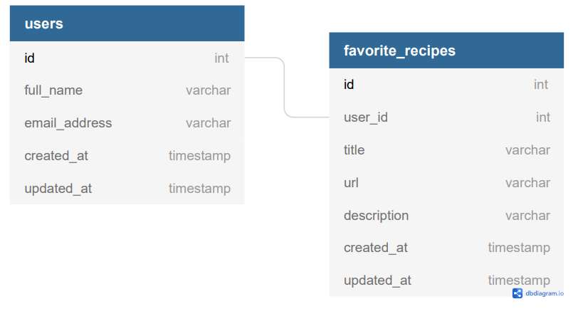

1. APIs to be used: Edamam and/or Spoonacular
2. Rough breakdown of tasks
   1. Repo Owner- Greg Hanstedt
   2. Front end:
      * Dexter Burns
      * Denise Quarles
      * Jerron McGinnis
      * Sean Stephens
   3. Back end:
      * Greg Hanstedt
      * Donna Clever
      * Richard Matthews